**Walmart Interview Questions**

1. code implementation for thread and a fair understanding of how threads work.
2. features and annotation usage of spring boot framework
3. write code for various apis of library management system
4. fir lambda expressions, streams and optionals and was able to write code with the same
5. how do you create multi threads in java
6. what is singleton design pattern in java
7. what is dependency injection in java
8. inversion of control in spring
9. what is the main features of java 8
10. what is flatmap in java
11. what is stream api in java with example
12. What is difference between REST and SOAP?
13. What is garbage collection java
14. What are the types of exception handling in java
15. Oops concept with example(abstraction , polymorphism , inheritance and encapsulation )
16. What is demon Thread
17. What is deadlocked and write the program for deadlock  in eclipse
18. What is Thread pool and write the program for print 1 to 100 in eclipse
19. What is singleton design pattern , write the code for singleton in eclipse
20. What is thread and  Write the program for simple thread.(just start the thread and print any think in run method)
21. Overriding / overloading concept
22. Private method can we override ?
23. What is out of memory, how will get , give example (hint if your loop condition is running infinite times then it will give java.lang.OutOfMemoryError)
24. Session tracking in servlet
25. What is Actuator and what is use
26. Write the step  for jdbc connection (also explain him about statement ,Prepare Statement and callable statement)
27. How to communicate one microservice to another microservice
28. Jsp explicit object
29. Factory Design pattern
30. Difference between IOC and DI
31. Difference between spring boot and spring
32. When I will use Synchronization
33. Write I program find middle element of list (not using inbuilt function)
34. Write a program for Reverse a string without affecting special characters (Input:   str = "Wal@ma&rt"  Output:  str = "tra@ml&aW")
35. What is difference between @SpringBootApplication , @EnableAutoConfiguration And @ComponentScan
36. Java concepts – OOPS, Multi-threading and Exception Handling
37. Linked List that adds elements at the beginning
38. definition of base path URL for RESTFUL Services
39. implementation of Honking pattern
40. advantages/disadvantages of Java 8 features

Object oriented - 4/5

Core Java concepts - 3/5

    Average, has good theoritical knowledge

Exceptions - 4/5

    Was able to explain the hirarchy and types

Collections - 4/5

    Good

Threads - 3/5

    Has baisc knowledge, not able to explain executers

Relational databse - 2/5

    Was not able to design basic table structe for 1 to many relation

Messaging Kafka - 2/5

    Not able to explain parition, offset commit

REST Api - 4/5

**Client Round 1**

**Practical**

Q1. Given a set of songs, say 10 songs. Play the songs such that

1. All the songs in a set will get played

2. songs will get played in random order.

(Write pseudo code for the logic applied and explain the time and space complexity. Answer should have only Big O(n) time and space complexity)

Q2. We wanted to design a system Price comparator

Samsung galaxy s10

Flipkart -- 40K

Amazon -- 40.6k

Reliance -- 42k

Tata cliq - 39.9k

Write REST API such that

1.Takes product name as input.

2. calls respective REST API of all given e-commerce platforms (Assume we have a contract with All Ecomm platform, and they haven us REST API) (REST API SLA is 5sec for each platform)

2.1 Flipkart

2.2 Amazon

2.3 Reliance

2.4 Tata cliq

3. return lowest price selling platform in our example tata Cliq (Answer should be done using multithreading concept)

**Theory**

1. Singleton classes
2. Different design patterns
3. Creative design pattern explanation and examples
4. Behavioral design patterns explanation and examples
5. Atomicity in Database
6. ACID properties in Database
7. Authorization, Authentication explanation and differences in Rest API.
8. How to increase security for REST APIs Identification in Rest API
9. HTTP response status codes

**Client round 2**

**Practical**

Q1. Given a parking lot system in a mall, where there are 3 categories of parking lot available, small, medium, and large, each of which can accommodate only two wheelers, four wheelers and heavy-duty vehicles, respectively. Every incoming vehicle is to be parked to its corresponding category if the space is available or given a message that the parking lot is full if there's no availability in that category

a) Design a system according to the above conditions. Explain architecture type (monolithic/microservices), tech stack used, database design in detail.

b) If the same system must support multiple parking lots in various malls, what should be the modifications to be done for the same.

c) How to deal with multiple incoming or outgoing vehicles at the same time at different check points of the mall. (Multithreading / Distributed systems)

**Theory**

1. How to maintain isolation in database design
2. ACID properties
3. Foreign key concepts
4. Identifying which fields to index
5. Difference between monolithic and microservice architecture

**Java  interview 1**

* Difference between Comparator and Comparable
* Comparable - Method
* Abstract Class and Interface
* Drawback of  Abstract Class
* Abstract class with only abstract method
* Abstract class with concrete method
* Collections
  + What kind of data set we used for sorting
  + Tree Set ??
* Design pattern
  + Name few patterns you are aware of
  + Explain one you have implemented in project
    - Singleton
  + Builder Design Pattern
  + Decorator Pattern
* Difference between thread and Process
* Types of Logs
* Springboot
  + Configuring bean
* Spring is based on basic concept
* Dependency injection means

 Coding

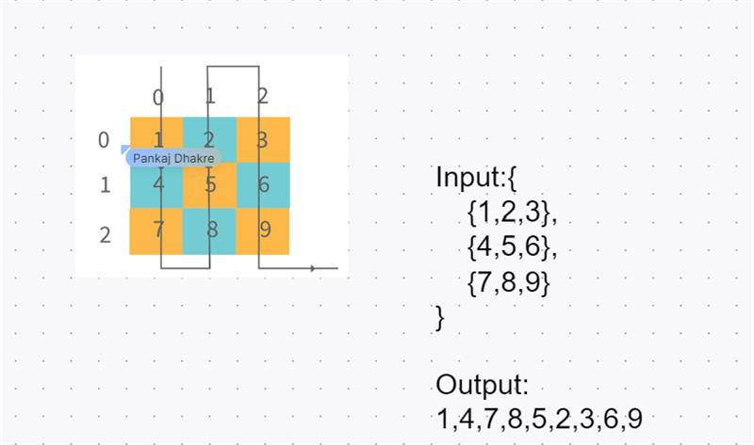

**Java  interview 2**

CPU optimization - Best Pratices

Heap memory and Stack memory   
Scope of Heap and Stack - for object

Find Output ??

 public static void main (String args[])  
    {  
        System.out.println(100 + 100 + "Str");  
        System.out.println(Str" + 100 + 100);  
    }

What are shallow copy and deep copy in java?

 Conditional beam creation in Spring

 Difference between @RestContoller and @controller

Difference between isa and hasa relationship in java   
Which is better ?Which is tight coupling ? Why

Array Sort Problem ? 1, 1, 0, 1, 0, 1, 0, 0, 0  
Elements in Array - Binary array   
Dynamically find number of 0 and 1

 Sub Questions

* Approach explain first   
  Arrays.sort shouldn’t be used   
  Space & time complexity in your solution

 Add element in tree set ?  
Logic to add ??

Time Complexity Influence

**Java ProdOPS(Production Support )**

Java  
----  
1. Difference between List and Set.  
2. What is NullPointerException?  
3. Output of below code:  
    String s = null;  
    System.out.println(s.length());  
4. Primitive Data Types.  
5. What is Multithreading, and how we implement it?  
6. OOPs Concept.  
7. Difference between Class and Interface  
8. Use of static keyword  
9. What is exception handling?  
10. Use of final, this and super keywords.  
11. Java 8 features

SQL  
---  
1. Concept of Joins.  
2. Basic query writing skill  
3. use of count and group by

Monitoring Related  
------------------  
1. which tool do you use for monitoring?  
2. Where do you check your logs?  
3. Discussion on any P1 or P2 incidents that you came across.  
4. Splunk query writing skills.  
5. Use of time chart in Splunk.  
6. What to do if an API is throwing 5xx error? How to know it’s due to which exception and how to deal with it thereafter?  
7. What to do if an API has high response?  
8. Discussion on any recent issue you came across while monitoring.  
9. What will you do if you find an application is down/crashed?  
10. Discussion on any Splunk dashboard you were part of while creating.

**Walmart Interview – Round 1**

1. Find the flight paths between source to destination airport.

/*

List of airports {A, B, C, D, E}

Flight path list {A-C, B-D, B-C, B-E, A-B, C-D}

Available paths to go from A to D -> A-B-D, A-B-C-D, A-C-D

*/

1. Print all permutation of a string.

// Input: String s = "ABC"

// Output: ABC ACB BAC BCA CAB CBA

Walmart customer Interview Questions: Round 1

1. find count of feature passed in each service

input: "Service1-Feture1-Passed"

"Service1-Feture2-Failed"

"Service2-Feture1-Passed"

Service2-Feture2-Passed

Ans- Service1- 1

Service2-2

1. Given a LinkedList

1-4-2-8-10-null

Update value of node with following condition -

If value is even put 0

If value is odd put 1

Ans - 1-0-0-0-0-null

1. Find 2nd largest no

Int a[]= {1,2,3,6,5} 2nd largest Ans =5

1. Suggest a collection to store Country-State-Capital. What Collection should provide easy insert and read just explain

Example: IN KAR BGL

1. Given a user table with (id, name, age) find all users whose name starts with a and age is more than 30
2. 1.Internal working of hash map
3. 2.In linked list how to find middle element
4. 3.what are the features of spring boot?
5. 4.There are two containers one is 5 litre and 3 litre and result  need to get 4 litre.
6. 5.How to get 3rd highest salary using MySQL
7. 6.In given string find out duplicates frequency
8. 7.what is serialisation in Java?
9. 8.what is @Autowired
10. 9.what is the usage of spring profiles

Walmart customer Interview Questions: 22/11/23

1)Previous project flow -in detail project topics

2)Kafka topics

3)Indexing in general(DBMS)

4)What data structure is used in indexing?

5)Hashmap -internal working

6)When and where to use different database : like relational and non relational

7)Normalisation and what is the drawback of it once it's normalised

8)Hash collissions

9)Java question : what is each term in public static void main(String args[])

10) Microservice architecture

11)Performance tuning of applications